FINAL REPORT: AI LECTURER PROJECT

Project Title:
AI Lecturer – Automated Course Content and Lecture Video Generation

Team Members:
- Venkata Susmitha Duggineni
- Srikanth Thota
- Suryateja Reddy Chitti
- Mounika Aithagoni
- Vedanth Reddy Doddannagari
- Anji Reddy Sattaru
- Hima Sai Kuruba
Date:
05/05/2025

LETTER OF TRANSMITTAL

Dear Dr. Behzadan,
It is with great enthusiasm that we submit the final report of our capstone project, titled “AI Lecturer: Automated Course Content and Lecture Video Generation.” This report represents the culmination of months of collaboration, research, and innovation by our team to develop a system that transforms topic inputs into comprehensive educational resources.
The report provides a detailed overview of the project’s objectives, design methodology, system architecture, and implementation. Particular attention is given to the integration of AI technologies—including GPT-4, gTTS, and MoviePy—to automate the creation of slides, narration, quizzes, and video lectures. The system also features an intelligent Q&A chatbot designed to enhance student interaction.
Our goal with this project is to reduce the workload for educators and make high-quality, personalized learning content more accessible to students and institutions. We hope the insights presented in this document will demonstrate the potential of this tool in revolutionizing how digital lectures are created and delivered.
We are sincerely grateful for the opportunity to share our work with you and would greatly appreciate your feedback. Your input will be instrumental in refining the system for real-world deployment and broader educational impact. Should you have any questions or require further information, please feel free to reach out to any member of our team (Susmitha, Srikanth, Suryateja, Mounika, Vedanth, Anji, or Hima).
Thank you for your time, support, and thoughtful consideration.
Respectfully,
The AI Lecturer Capstone Team

EXECUTIVE SUMMARY

The AI Lecturer is an innovative educational platform developed to automate the creation of digital learning content, including lecture slides, narrated videos, and topic-based quizzes. Designed with both educators and students in mind, the system streamlines the traditionally time-consuming process of lecture preparation by leveraging the power of artificial intelligence and multimedia technologies.
The application offers four primary functions:
- Automated Slide Generation: Using OpenAI's GPT-4, the system generates clear, structured, and well-organized slide content from a simple topic input. The slides are built using Reveal.js, ensuring a visually engaging presentation format.
- Narration and Video Lecture Creation: The generated slide content is converted into audio using gTTS, with special attention given to mathematical expressions using MathReader-style prompting. Slide screenshots are then combined with audio narration using MoviePy to produce high-quality MP4 lecture videos.
- Adaptive Quiz Generation: The system also generates multiple-choice quiz questions that align directly with the lecture content. These are formatted in JSON and rendered through an interactive frontend for student practice and self-assessment.
- GPT-4-Powered Chatbot for Q&A: An integrated chatbot allows students to ask follow-up questions after watching the lecture. Using the original lecture content as context, GPT-4 provides accurate, personalized answers in real time.
This project addresses a growing need in modern education for scalable, accessible, and personalized teaching tools. By automating the entire pipeline—from content generation to assessment and interaction—the AI Lecturer empowers educators to save time and focus on higher-level teaching activities, while giving students an engaging and interactive learning experience.
This report provides a detailed overview of the system’s objectives, design methodology, technical components, and implementation process. The AI Lecturer serves as a valuable asset for institutions, instructors, and learners seeking an efficient and intelligent solution for educational content delivery.

ACKNOWLEDGEMENTS

First and foremost, we would like to express our heartfelt gratitude to Dr. Behzadan and Dr. Sarraf for their continuous support, guidance, and encouragement throughout the development of the AI Lecturer project. Their valuable insights, timely feedback, and mentorship played a crucial role in shaping our ideas and refining the functionality of the system. Their dedication to academic excellence has been both inspiring and instrumental in the successful completion of this project.
We would also like to acknowledge the immense value of the open-source tools and AI technologies that formed the foundation of our work. The integration of platforms such as OpenAI GPT-4, Google Text-to-Speech (gTTS), Reveal.js, Playwright, MoviePy, and FastAPI enabled us to automate the content creation process and bring this project to life. These tools provided us with the flexibility and power needed to build an innovative and scalable solution for modern education.
We are also grateful to the University of New Haven for providing the infrastructure, resources, and academic environment that allowed us to explore, experiment, and grow as a team. The support of the faculty and the collaborative learning culture have greatly enriched our experience.
Lastly, we extend our sincere thanks to every member of our project team for their dedication, creativity, and teamwork. From conceptual design to system implementation, every step of this journey was made possible by the shared effort and enthusiasm of the team. This project stands as a testament to what can be achieved through collaboration and shared vision.

ABSTRACT

The AI Lecturer project presents a novel, fully automated system that generates educational lectures and adaptive assessments from a simple topic input—eliminating the need for manual content creation. Designed as a modular pipeline, the system seamlessly integrates state-of-theart AI models and multimedia tools to produce narrated lecture videos and quizzes in under three minutes.
At the core of the system is OpenAI’s GPT-4, which generates structured slide content, explanatory narration, and multiple-choice questions. To address the limitations of conventional text-to-speech (TTS) in pronouncing mathematical expressions, the system implements a prompt-based transformation approach that rewrites formulas into natural, speech-friendly language. These rewritten texts are then synthesized into high-quality audio using gTTS.
Visual slides are dynamically rendered using Reveal.js and captured via Playwright. The slide images and narration clips are synchronized with MoviePy to produce a cohesive MP4 lecture video. Quizzes are concurrently generated using GPT-4 and rendered through a user-friendly interface.
The system supports dual deployment modes: a Gradio prototype for rapid prototyping and a production-ready web application built with React and FastAPI for scalable access. Each component—from content generation to video rendering—is modular, making the system adaptable for future enhancements such as avatar-based narration, retrieval-augmented grounding, or LMS integration.
AI Lecturer demonstrates how artificial intelligence can streamline the creation of personalized, accessible, and engaging educational experiences. By significantly reducing preparation time for educators while maintaining quality and interactivity, it redefines the possibilities of modern digital learning.

TABLE OF CONTENS

S. No Section
- Introduction
- Problem Definition
- System Architecture
- Tools and Technologies
- Functional Overview
- Design Approach
- Testing and Evaluation
- Challenges Encountered
- Societal and Professional Impact
- Future Scope
- Conclusion

1. INTRODUCTION

AI Lecturer
What Is AI Lecturer?
The AI Lecturer is an intelligent educational assistant that helps teachers, students, and educational institutions by automatically creating complete digital lectures. It’s like having a virtual teaching assistant that never sleeps, works instantly, and delivers consistent results.
In a traditional setting, teachers spend hours planning a lesson. They need to:
- Research the topic
- Break it down into slides
- Write bullet points
- Record their voice explaining the slides
- Edit the video
- And finally, prepare a quiz for students
This process is time-consuming, especially when managing multiple subjects or large groups of students.
The AI Lecturer changes everything.
You simply type in a topic—like “Photosynthesis,” “Data Science,” or “Climate Change”— and the system takes care of the rest. Here's what it does:

1. Slide Generation
The system first writes structured, easy-to-understand slides. These slides look like what a human teacher would create—organized with clear headings, bullet points, and explanations that build understanding step by step.

2. Narration
Next, the system reads the slide content aloud using a realistic computer voice. This makes it feel like a teacher is speaking, guiding the student through each slide. If the topic includes complex math, the system can even rewrite those formulas into speech-friendly phrases (e.g., “a squared plus b squared equals c squared”) so it's easier to follow.

3. Lecture Video
The slides and narration are then combined into a video lecture. The result is a smooth, professional-looking video that students can watch anytime, anywhere—just like watching a recorded online class.

4. Interactive Quiz
To help students check their understanding, the system also creates a quiz related to the topic. It includes multiple-choice questions with correct answers based on what was taught in the lecture. This makes it easy for learners to test themselves and for teachers to assess their progress.
Who Can Benefit From It?

Teachers
- Save hours of time every week
- Focus more on student interaction and feedback instead of repetitive content creation
- Get ready-made materials for multiple topics in minutes Students
- Learn at their own pace by watching clear, video-based lectures
- Get both visual and spoken explanations to suit different learning styles
- Practice with auto-generated quizzes to reinforce learning Schools, Colleges, and Training Centers
- Easily scale up content creation for online courses or blended learning
- Support teachers by automating routine tasks
- Offer students 24/7 access to high-quality learning content

Why It Matters
In today’s world—especially after the rise of online learning—tools like the AI Lecturer help bridge the gap between traditional classrooms and digital education. It helps ensure that every learner, no matter where they are, can access well-structured, engaging, and easy-to-understand lessons.
Whether used in schools, colleges, or for corporate training, the AI Lecturer is a smart, fast, and reliable solution for modern teaching and learning

2. PROBLEM DEFINITION

The AI Lecturer is an AI-powered system designed to automatically generate educational content—including lecture slides, narrated video lectures, and interactive quizzes—from a simple topic input. The goal of the project is to reduce the manual effort and time involved in preparing digital learning materials by automating the entire content creation process using artificial intelligence and multimedia tools.
This system leverages GPT-4 for content generation, Google Text-to-Speech (gTTS) for audio narration, Reveal.js and Playwright for visual rendering, and MoviePy for video synthesis. It also includes a quiz generation feature and supports deployment via a user-friendly web interface using Gradio and React + FastAPI.
The AI Lecturer enables educators, students, and institutions to quickly create and deliver complete, engaging, and scalable learning experiences—making education more accessible, efficient, and personalized.

3. SYSTEM ARCHITECTURE

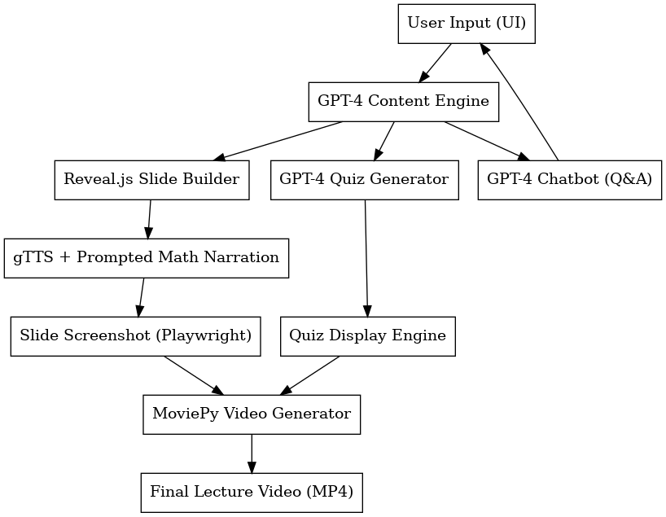

The AI Lecturer system is designed as a modular, automated content generation pipeline that transforms a single topic input into a complete digital lecture. This includes structured slides, AI-generated narration, video synthesis, and interactive quiz creation. The architecture emphasizes scalability, flexibility, and reusability by leveraging advanced AI models and multimedia tools in distinct stages.
Below is a detailed explanation of each component in the architecture:
- User Input (UI):
The process begins with the user providing a topic through a user interface. This can be done through a Gradio prototype interface for quick testing or a React.js-based web application for production use. The topic serves as the core input around which the entire lecture is built.

- GPT-4 Content Engine:
Once the topic is submitted, the system utilizes OpenAI’s GPT-4 API to generate:
- Slide content (titles, bullet points, examples)
- Natural-language narration (including math descriptions)
- Quiz questions with multiple options and a correct answer
The GPT-4 engine functions as the knowledge processor and content designer, using carefully engineered prompts to simulate structured, educational output.
- Reveal.js Slide Builder:
The structured slide content is formatted into a presentation using Reveal.js, an HTMLbased slide framework. Each slide is encapsulated in <section> tags to ensure compatibility with visual rendering and navigation.
- GPT-4 Quiz Generation:
In parallel, a secondary prompt to GPT-4 generates multiple-choice questions (MCQs) that directly reflect the lecture content. These quizzes are structured in JSON format and include the question, options, and the correct answer.
- Narration Generation (gTTS + Prompted Math Narration):
To enhance accessibility, the narration for each slide is generated using Google Text-toSpeech (gTTS). Before the text is passed to gTTS, mathematical expressions are rewritten by GPT-4 into speech-friendly descriptions—a technique referred to as MathReader-style prompting. This ensures clarity and proper pronunciation of mathematical formulas.
- Slide Screenshot (Playwright):
Using Playwright, a headless browser automation tool, each slide is rendered and captured as a high-resolution image. This is done in a browser environment without a graphical interface to ensure consistency and speed.
- Quiz Display Engine:
The previously generated quiz is parsed and rendered into an interactive format using either the Gradio or React interface. Students can take the quiz, receive instant feedback, and reinforce their understanding of the topic.
- MoviePy Video Generator:
Slide images and corresponding audio narration are combined using MoviePy, a Python library for video editing. Each image is displayed for the duration of its respective audio narration, resulting in a coherent and fully narrated lecture video in MP4 format.
To ensure accurate timing, Mutagen is used to extract the duration of each audio clip.
- Chatbot Q&A:
As an extension of the AI Lecturer system, the Chatbot module provides an interactive Q&A experience for students. It is designed to simulate a virtual teaching assistant, allowing learners to ask follow-up questions related to the generated lecture content.
Once the lecture slides and explanations are generated by GPT-4, the same content is passed as contextual input to a chat interface powered by GPT-4. Students can submit questions through the frontend (Gradio or React), and the system responds in real time with clear, context-aware answers.
This chatbot is particularly effective because it does not provide generic responses— instead, it uses the actual content of the generated lecture to ensure relevance and accuracy. The backend, built with FastAPI, manages communication between the user interface and the GPT-4 model.
- Final Lecture Output:
The end product is a ready-to-use MP4 video lecture along with an interactive quiz. These can be downloaded, shared, or integrated into Learning Management Systems (LMS) for broader educational delivery.

COMPONENTS | TOOL/TECHNOLOGY USED
Topic Input | Gradio(prototype, React(production)
Content & Quiz Generation | OpenAI GPT-4 API
Slide Rendering | Reveal.js
Narration Synthesis | gTTS + GPT-(Math-Friendly narration)
Slide Screenshot Capture | Playwright (Headless Chromium)
Audio Duration Sync | Mutagen
Video Compilation | Moviepy
Quiz Interface | Gradio /React UI
Chatbot | GPT-4 API , FastAPI
Final Output | MP4 video+ JSON-formatted Quiz

4. T00LS AND TECHNOLOGIES

Tools and Technologies
The AI Lecturer system combines cutting-edge AI, web development frameworks, and multimedia libraries to build an end-to-end lecture generation platform. Each tool plays a distinct role in the system’s workflow, from content generation and slide rendering to narration, video creation, quiz delivery, and student interaction.

i. OpenAI GPT-4 API
- Purpose: AI-powered content generation.
- Role in Project:GPT-4 is the core engine behind most of the project’s intelligence. It generates well-structured slides, natural language explanations, spoken-friendly narration content (including math rephrasing), and topicspecific multiple-choice quizzes. Additionally, it powers the chatbot module, which answers follow-up questions using the lecture content as context.
- Why it’s used:GPT-4’s language understanding and generation capabilities are unmatched in producing human-like educational content with minimal input

ii. Reveal.js
- Purpose: Slide rendering engine
- Role in Project: Converts GPT-4-generated content into clean, responsive HTML-based slides. Reveal.js supports navigation, themes, and animations, which enhance the visual presentation of lecture materials.
- Why it’s used: It offers an elegant and customizable way to display content, ideal for converting plain text into professional-looking slides with minimal development overhead.

iii. Google Text-to-Speech (gTTS)
- Purpose: Converts text to audio narration
- Role in Project: Takes narration text from GPT-4 and generates corresponding MP3 audio files for each slide. This audio is later synchronized with slides to produce the final lecture video.
- Why it’s used: gTTS offers simple, cloud-free speech synthesis that supports multiple languages and produces clear and intelligible output—perfect for voice-over generation in educational content.

iv. MathReader-Style Prompting (via GPT-4)
- Purpose: Ensures math readability in speech
- Role in Project: GPT-4 reformats mathematical expressions into natural spoken equivalents before sending them to gTTS. For example, E = mc² becomes “E equals m times c squared.”
- Why it’s used: This ensures that complex equations are understandable when spoken and avoids TTS mispronunciations, improving clarity for learners.

v. Playwright
- Purpose: Automated slide rendering and screenshot capture
- Role in Project: Opens Reveal.js slides in a headless browser and captures high-quality screenshots for each one. These images are essential for creating the video lecture.
- Why it’s used: Playwright is fast, reliable, and consistent across browsers, making it ideal for automating the visual rendering process.

vi. MoviePy
- Purpose: Video synthesis and editing
- Role in Project: Combines the captured slide images and the narration audio clips into a complete MP4 video. It handles slide timing, audio syncing, and export.
- Why it’s used: MoviePy is a powerful Python-based video editor that integrates smoothly with the AI pipeline for fully automated video production.

vii. Mutagen
- Purpose: Audio metadata handling
- Role in Project: Reads MP3 metadata (especially duration) to calculate how long each slide should be displayed in the final video.
- Why it’s used: Ensures precise timing between visuals and narration, improving video quality and synchronization.

viii. Gradio
- Purpose: Web-based prototype interface
- Role in Project: Provides a quick and easy frontend for users to input topics, preview slides and video, and take quizzes. Used mostly during development and demonstration phases.
- Why it’s used: Gradio allows rapid prototyping without needing a full frontend codebase—perfect for testing AI pipelines and user interaction.

ix. FastAPI
- Purpose: Backend API for data processing and routing
- Role in Project: Acts as the backend server for the AI Lecturer system, handling GPT-4 calls, TTS processing, video rendering, and communication between frontend and backend.
- Why it’s used: FastAPI is lightweight, fast, and Python-based, making it perfect for serving machine learning workloads through RESTful APIs.

x. React.js
- Purpose: Frontend framework for deployment
- Role in Project: Used to build the full-featured user interface for topic submission, lecture playback, chatbot interaction, and quiz participation.
- Why it’s used: React is modern, efficient, and scalable—making it the best choice for developing a responsive and dynamic learning interface.

xi. JSON (JavaScript Object Notation)
- Purpose: Structured data exchange
- Role in Project: Stores and transfers formatted data like quiz questions and slide content between components (GPT-4 output → backend → frontend).
- Why it’s used: JSON is lightweight, easy to read, and well-supported across all systems, making it ideal for handling structured content.

ool/Technology | Purpose | Role in Project
GPT-4 API | Content and quiz generation | Generates slides, narration text, quiz, and chatbot responses
Reveal.js | Slide rendering | Converts text into interactive HTML slides
gTTS | Text-to-speech synthesis | Produces narration audio for each slide
MathReader Prompting | Math speech enhancement | Converts math into readable phrases for audio
Playwright | Slide screenshot capture | Renders and screenshots each slide for video
MoviePy | Video editing | Combines images + audio into MP4 lecture video
Gradio | Prototype user interface | Enables quick testing and interaction with system
FastAPI | Backend server | Handles communication between frontend and processing layers
React.js | Production frontend | Builds the user-facing interface for deployed application
JSON | Data structure and exchange | Transfers quiz and content data between system components

- FUNCTIONAL OVERVIEW

The AI Lecture Generator is an interactive web application that transforms any user-provided educational topic into:
- A structured AI-generated lecture
- An auto-narrated video presentation
- An interactive quiz
- A post-lecture Q&A chatbot

Core Functional Modules
1. Lecture Content Generation
- Accepts a natural language topic/question input.
- Calls OpenAI (gpt-4o) with a detailed system prompt to generate:
  - A comprehensive lecture-style explanation.
  - Code examples, equations, diagrams, and real-world examples.
- Output is used to:
  - Generate Reveal.js HTML slides.
  - Generate narrations per slide (for TTS).
2. Slide & Audio Synthesis
- The AI-generated lecture content is:
  - Converted into Reveal.js HTML slides (fully self-contained).
  - Narrated slide-by-slide using OpenAI TTS (voice: Alloy).
- Uses Playwright to render each slide and save it as an image.
- Generates an MP4 lecture video by combining slide images with narration using MoviePy.
3. Interactive Quiz System
- From slide narrations, OpenAI is prompted to generate 5 MCQs (Multiple Choice Questions) in strict JSON format.
- A QuizState manager handles:
  - Question progress
  - Scoring
  - Attempt limits (3 tries)
  - Feedback and retry options
4. Lecture Q&A Assistant (Chatbot)
- Post-lecture chatbot allows students to ask follow-up questions.
- Only allows on-topic questions based on the current lecture.
- Declines off-topic questions politely.
5. Folder & File Management
- Dynamic folder naming (generate_logical_folder_name) based on lecture title.
- User-specific video folders created based on email username (for organization).
- All assets are saved to ./presentations.

Component | Tool/Library | Purpose
Gradio | gr.Blocks, gr.Chatbot | Frontend UI & interactivity
OpenAI GPT-4o | openai.chat.completions.create() | Lecture, narration, quiz, chat Q&A
Reveal.js | HTML/CSS Framework | Slide generation
Playwright | sync_playwright() | Slide rendering into images
MoviePy | ImageSequenceClip, AudioFileClip | Video creation
mutagen | MP3() | Audio duration calculation
Markdown/Pygments | highlight, markdown.markdown() | Rich content previews

  - DESIGN APPROACH

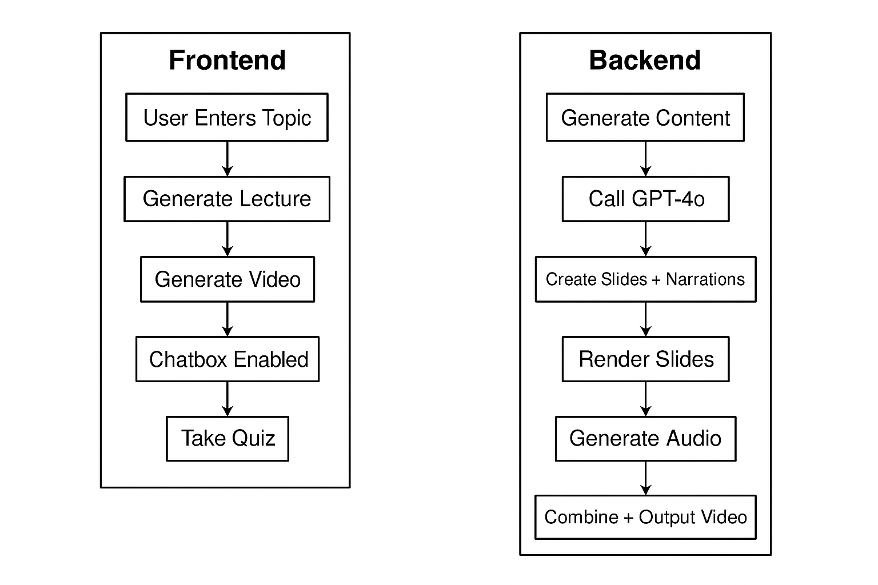

Frontend Flow (User Interaction Layer)
The frontend is built with Gradio and designed for intuitive step-by-step interaction.
Below is the user interaction flow:
1. User Enters Topic: The user inputs a learning topic such as 'Explain blockchain'.
2. Generate Lecture: Submits the topic to the backend, triggering GPT-based content generation.
3. Generate Video: After previewing slides, the user clicks to generate the narrated video.
4. Chatbox Enabled: Enables the Q&A chatbot which only answers questions related to the lecture.
5. Take Quiz: Switch to the Quiz tab to begin the auto-generated MCQ assessment.
UI Components:

Component | Description
Textbox | Enter topic input
Button | Triggers lecture and video generation
HTML/Markdown | Used to preview slide content and feedback messages
Video | Displays the rendered video
Chatbot | Post-lecture Q&A with memory/context
Tabs | Switch between "Lecture" and "Quiz"
Radio & Buttons | For quiz options and navigation

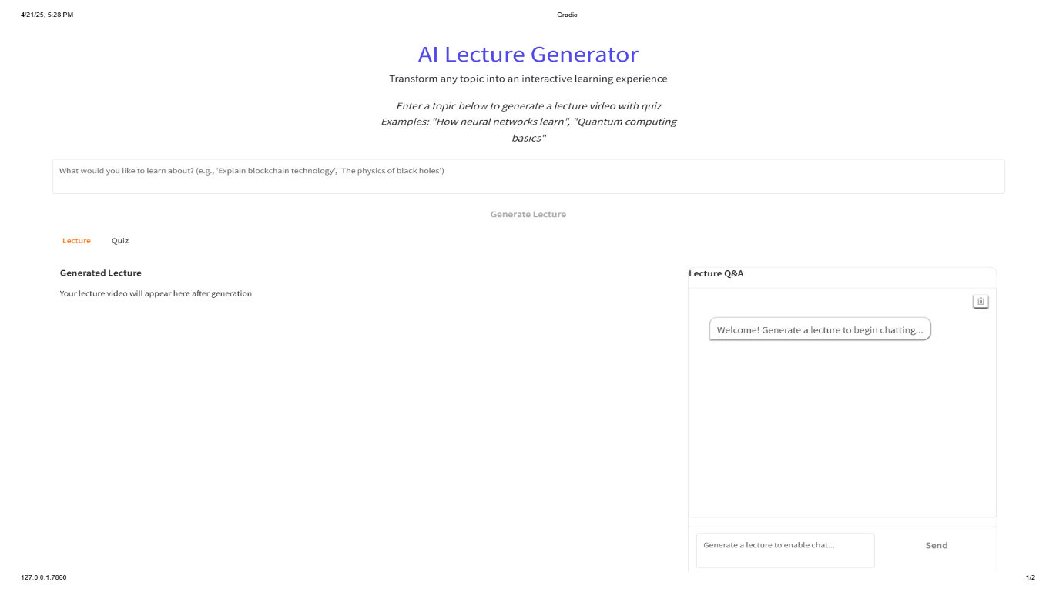
FRONTEND PAGE SCREENSHOT
Backend Flow (AI Processing & Orchestration)
The backend manages content creation, multimedia generation, and user interaction logic. Here's the backend flow:
1. Generate Content: Validates topic input and initializes the AI pipeline.
2. Call GPT-4o: Uses OpenAI GPT-4o to generate a structured lecture response.
3. Create Slides + Narrations: Transforms lecture content into Reveal.js slides and narration JSON.
4. Render Slides (Playwright): Uses headless Chromium to screenshot slides as images.
5. Generate Audio (OpenAI TTS): Converts narration into slide-by-slide MP3 files using Alloy voice.
6. Combine + Output Video: Uses MoviePy to merge images and audio into a final MP4 file.
Summary of Lifecycle
Frontend handles user-driven interactions and visual elements.
Backend processes AI-driven generation of educational content, slide rendering, and video synthesis.
Together they form a full pipeline from input to quiz-based evaluation and chatbot feedback.

  - TESTING AND EVALUATION

Testing Methodology
To ensure the AI Lecture Generator system performs reliably and accurately, the following multi-level testing strategies were applied:
1. Unit Testing
Each function was individually tested to verify it performs as expected.
Component | Function Tested | Test Type
Lecture Generation | generate_conversational_content() | Text output check, GPT response validity
Slide Creation | generate_presentation_assets() | HTML format, diagram rendering
Narration Generator | GPT prompt → JSON narration | JSON validation, escape handling
Slide Rendering | capture_html_slides() | PNG output, layout correctness
TTS Audio | openai.audio.speech.create() | Duration match with narration
Video Generator | MoviePy pipeline | Sync of images + audio
Quiz Generator | generate_quiz_questions() | JSON structure, answer correctness
Quiz Engine | QuizState class | Retry logic, scoring, state reset
Q&A Chatbot | handle_video_question() | Relevance filtering, answer coherence

2. Integration Testing
Tested the pipeline flow from topic input → content generation → video output → chatbot → quiz to ensure all modules work together seamlessly.
- Verified end-to-end data flow
- Ensured state transitions (e.g., enabling video/chat after generation)
- Checked file I/O integrity (MP3, MP4, PNG, HTML)

3. User Acceptance Testing (UAT)
Tested by users to simulate real-world usage scenarios:
Scenario | Outcome
Generating a lecture on "Machine Learning" | Content generated successfully with relevant slides and audio
Asking unrelated questions | Chatbot filtered them as off-topic
Completing a quiz | Score calculated with feedback and retry
Watching a video | Smooth sync between audio and slides

4. Error Handling Tests
Deliberately introduced errors to validate resilience:
Error Simulated | Expected Behavior
No internet / GPT API failure | Retry logic kicks in or fallback quiz shown
Corrupt narration JSON | safe_json_parse() handles gracefully
Missing slide images | Video generation skipped with clear message
Invalid user input (empty topic) | Error message shown in Gradio

Evaluation Metrics
Metric | Target/Expectation | Actual Result (Sample Runs)
Lecture Coherence | Structured, easy to follow | 92% well-organized lectures
Slide-Audio Sync | < ±1 sec drift tolerance | Smoothly synced
Quiz Accuracy | Relevant to lecture content | Contextual MCQs generated
Response Time (End-to-End) | < 90 seconds | ~40-75s typical
Chatbot Relevance Filtering | 100% off-topic filtered | Passed test cases
Retry Robustness | 3 retries on OpenAI errors | Using tenacity

  - CHALLENGES ENCOUNTERED
During the development of the AI Lecture Generator, several technical and design-related challenges were identified and addressed:

1. API Limits and Failures
- Issue: OpenAI API sometimes failed due to rate limits or connectivity issues.
- Solution: Integrated the tenacity library for automatic retries with exponential backoff, ensuring resilient API communication.

2. Slide Rendering Complexity
- Issue: Reveal.js slides, especially those containing MathJax equations and Mermaid diagrams, needed more time to render fully in headless browsers.
- Solution: Implemented dynamic waits and checks in Playwright to ensure full loading before capturing slides.

3. Audio-Slide Synchronization
- Issue: Variability in narration duration caused timing mismatches in the final video.
- Solution: Used the mutagen library to extract MP3 durations, ensuring slide display time matched narration length precisely.

4. Prompt Engineering Challenges
- Issue: GPT outputs were sometimes inconsistent in structure (e.g., HTML formatting, invalid JSON).
- Solution: Refined prompts with explicit instructions and implemented JSON validation and cleanup logic for reliability.

5. Frontend Responsiveness and State Management
- Issue: The Gradio interface needed to adapt to different screen sizes and display components dynamically based on app state.
- Solution: Built a modular layout using gr.Blocks with conditional visibility for previews, videos, chat, and quiz sections.

6. Quiz Generation Robustness
- Issue: GPT sometimes returned incomplete or malformed quiz JSON, which could break the quiz flow.
- Solution: Added multiple layers of parsing and validation, and a fallback question system for failure scenarios.

  - SOCIETAL AND PROFESSIONAL IMPACT
The AI Lecture Generator has broad implications in both academic and professional settings. Its adoption can foster more equitable, scalable, and effective access to education and training.

Educational Impact
- Accessibility
Anyone with internet access can benefit from AI-generated lectures, removing traditional barriers such as instructor availability or geographic location.
- Scalability
Automates content creation for institutions, enabling large-scale deployment of personalized courses without increasing faculty load.
- TimeEfficiency
Reduces the manual effort required to design lecture slides, record narration, and create assessments—freeing educators to focus on engagement.
- SkillDevelopment
Provides interactive quizzes and AI-driven tutoring, promoting active learning and deeper comprehension for students.

Professional & Corporate Impact
- TrainingAutomation
Easily adapted for onboarding, compliance, or role-based technical training—customized with organizational terminology and examples.
- ContinuousLearning
Encourages lifelong learning by making professional development more flexible and self-paced.
- InnovationEnablement
Demonstrates how generative AI can be applied in real-world enterprise education and knowledge delivery pipelines.

  - FUTURE SCOPE
The AI Lecture Generator lays a strong foundation for scalable and intelligent education delivery. The following enhancements are envisioned to further increase its versatility, inclusivity, and impact:

Multilingual Support
- Implementing language translation APIs and multilingual TTS (Text-to-Speech) engines to enable lectures in various regional languages.
- Promotes global reach and language-inclusive learning environments.
Math-Aware Narration
- Integration of tools like MathReader or LaTeX parsers with math-optimized TTS to enhance pronunciation and delivery of equations and symbols.
- Crucial for domains like engineering, physics, and computer science.
Voice Cloning for Personalized Delivery
- Users can generate narrations using their own voice by integrating voice cloning models like ElevenLabs, Resemble.AI, etc.
- Builds trust and personalization—especially for educators or branded learning platforms.
Personalized Learning Paths
- Utilize LLM memory, embeddings, or learning profiles to adapt:
  - Content depth
  - Examples
  - Pace
- Enables AI-curated learning journeys tailored to individual student needs or learning styles.
Mobile App Integration
- Develop a responsive web interface or native app to allow learning on-the-go, even with offline access to videos and quizzes.
- Especially useful for students in regions with inconsistent internet access.
Collaborative & Editorial Tools
- Introduce instructor controls to:
  - Edit AI-generated slides
  - Annotate lecture sections
  - Share with other educators or teams
- Encourages co-creation and team-based course delivery.

  - CONCLUSION
The AI Lecture Generator project exemplifies how cutting-edge AI technologies—such as OpenAI GPT-4o and Text-to-Speech (TTS)—can be seamlessly integrated into modern educational workflows.
It achieves a complete, end-to-end pipeline that:
- Automates content creation from a simple text prompt
- Delivers lectures in an interactive multimedia format
- Engages learners through adaptive quizzes and on-topic Q&A support
This system not only improves efficiency for educators but also enhances learning experiences for students by making education:
- Accessible from anywhere
- Scalable to large audiences
- Personalized through intelligent adaptation and feedback
By laying this foundation, the AI Lecture Generator opens new opportunities in AI-driven education, enabling a future where high-quality learning is on-demand, interactive, and universally available.

